CPE316 – Embedded Systems Final Project Report

Simple Arcade Game : Snake

Semester II (2021-2022)

|  |  |
| --- | --- |
| Course supervisors:  Dr. Iman Elawady  ENG. Michael B.Khani | Team STRAWBERRIES members:  Enes YURDATAPAN, 1810205079@ogrenci.karabuk.edu.tr*  Ali Eren ERGÜN, 1810205041@ogrenci.karabuk.edu.tr  Ali Ramazan TAŞDELEN, 1910205003@ogrenci.karabuk.edu.tr  Batıkan CIMBIT, 1810205043@ogrenci.karabuk.edu.tr  Kamoliddin FATKHIDDINOV, 1910205506@ogrenci.karabuk.edu.tr  Ahmat SOUMAINE, 1810205023@ogrenci.karabuk.edu.tr  Sevgican KILIÇ, 1810205078@ogrenci.karabuk.edu.tr  Oğuzhan PORTAKAL, 1810205048@ogrenci.karabuk.edu.tr |

Contents

1. Introduction 3

2. Related Works 3

3. Project Design 3

3.1. Hardware 3

3.2. Software 5

4. Conclusion and Results 6

5. Lesson Learnt 6

6. References 6

7. Attachments 7

7.1. Project images 7

7.2. Code Modules 9

## Introduction

Due to the increase in the demand for the entertainment sector and mobile devices, it is possible to see that the sales in this sector have been at the highest point recently.

One of the most important points of winning in this sector is to be able to promote the product very well and to produce it cheaply.

We aimed to integrate traditional game which is an indispensable childhood enjoyment that people always remember, in a modern way.

We wanted to design it not only as a toy for children, but also for adults as a way of entertainment while waiting in line in anywhere or on a long journey.

We started our project at 10th of April and finished successfully at 17th of May.

## Related Works

As a result of our research, we can see many such toys in the markets. We noticed a lot of attention despite their simple design. We analyzed the comments on these sales, identified the deficiencies and errors, and concluded that they would sell more when we fixed them.

We realized that the ones on the market usually appeal to children, so we added a challenging mode to our game and made it a place that adults can enjoy as well. There was a deficit in this area in the market, we thought of closing the gap by turning it into profit.

## Project Design

### Hardware

**Analog Joystick**

We first researched different button hardware to control the game and found the analog joystick to be the most useful.

Provided connections by connecting the appropriate pins on the analog joystick to the appropriate analog pins on the ESP32.

sfdsfsfsdf
 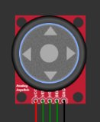

Analog Joystick Analog Joystick in the WOKWİ

**8x8 LED Dot Matrix**

In order to view the game, a hardware was needed. We decided that the one suitable for our project was LED Dot Matrix.

Our game and menu screen was created by connecting 16 8x8 matrices. By connecting 4 of them separately to the upper part, it was possible to view the scores. Connecting the cables was difficult.

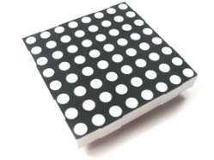 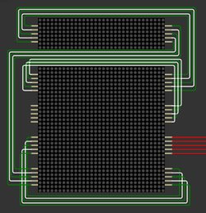

8x8 LED Dot Matrix 20 of 8x8 matrices connected to each other as output hardware

**ESP32**

We used ESP32 together with the wokwi simulator as it is well applicable with Micropython and simulation.

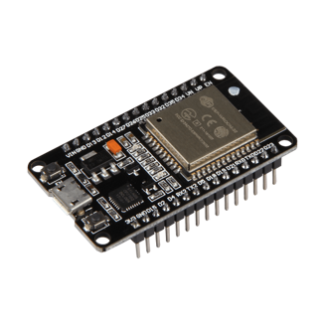 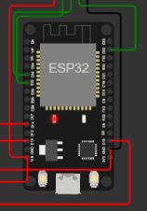

ESP32 ESP32 in the WOKWI

### Software

**MAX7219 Driver**

The specially assembled LED monitor used needed a driver to work with ESP32. Open source MAX7219 driver using SPI connection interface was found from internet. But this driver only works for 8x8 single matrix. It was showing the opposite on the special screen we used. We changed some codes and adapted them to our own matrix.

**Game Engine**

Actually, our entire game consists of game engine. Inspired by the snake game engines we found as a result of our research, we wrote our own game engine from scratch.

Game Engine includes important submodules such as random bait and wall creation, display and mod functions. We tried to improve the code as much as we could.

**Game Menu**

We have created a menu to select difficulty modes and switch to the game. It can also be developed in the future to select different games.

## Conclusion and Results

Prototype was used for testing trade-offs and consistency of product. As a result of the our project simulated in Wokwi environment, we came to the conclusion of a physical product is plausible.

Most of project time used for software part was advantage of using a virtual environment and developing the game.

Due of simulation platform and python environment we can’t solve problems related to speed of the snake.(real baud rate differs from simulated one)

## Lesson Learnt

As a result of our project, we got acquainted with the wokwi simulation and micropython environment. We learned how to write our own library and develop it by optimizing it and how to schedule projects better in coordination with teamwork.

## References

* Arduino Simulator: Uno, Mega, ESP32, FastLED, LCD1602, Servo, Raspberry Pi Pico, Sensors. Designed for makers, by makers. <https://wokwi.com/projects/328974406829212243>
* <https://github.com/csdexter/MAX7219>
* <https://github.com/coding-world/max7219>
* <https://github.com/adafruit/Adafruit_CircuitPython_MAX7219>
* <https://www.w3schools.com/python/>

## Attachments

### Project images

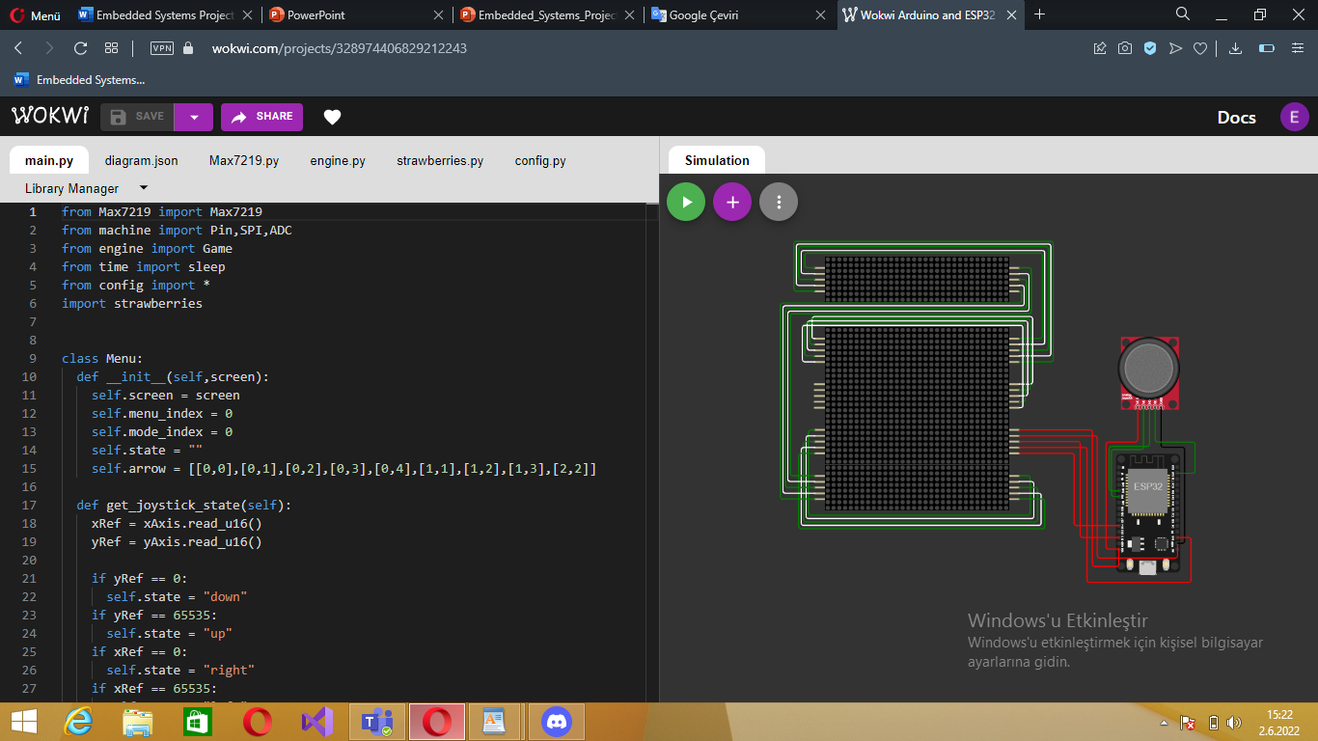

metin, skorbord içeren bir resim

Açıklama otomatik olarak oluşturuldumetin, elektronik eşyalar, açık hava, işaret içeren bir resim

Açıklama otomatik olarak oluşturuldu

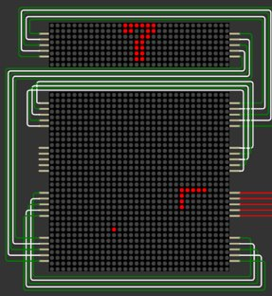 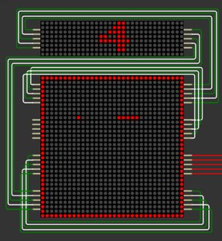

Easy Mode Normal Mode

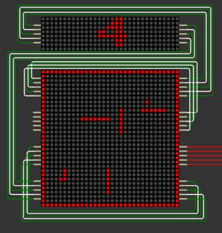 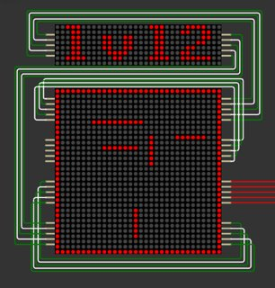 Hard Mode

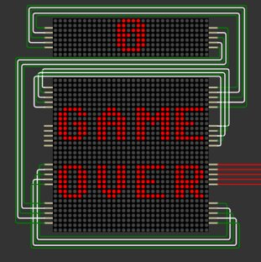 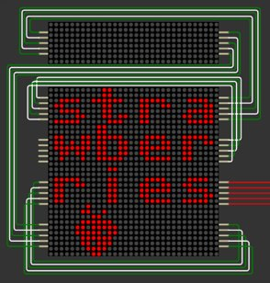

### Code Modules

#### main.py

|  |  |
| --- | --- |
| 1  2  3  4  5  6  7  8  9  10  11  12  13  14  15  16  17  18  19  20  21  22  23  24  25  26  27  28  29  30  31  32  33  34  35  36  37  38  39  40  41  42  43  44  45  46  47  48  49  50  51  52  53  54  55  56  57  58  59  60  61  62  63  64  65  66  67  68  69  70 | from Max7219 import Max7219  from machine import Pin,SPI,ADC  from engine import Game  from time import sleep  from config import *  import strawberries    class Menu:  def __init__(self,screen):  self.screen = screen  self.menu_index = 0  self.mode_index = 0  self.state = ""  self.arrow = [[0,0],[0,1],[0,2],[0,3],[0,4],[1,1],[1,2],[1,3],[2,2]]    def get_joystick_state(self):  xRef = xAxis.read_u16()  yRef = yAxis.read_u16()    if yRef == 0:  self.state = "down"  if yRef == 65535:  self.state = "up"  if xRef == 0:  self.state = "right"  if xRef == 65535:  self.state = "left"    def display_menu_default(self):  self.screen.fill(0)  self.screen.text("MENU",0,32,1)  self.screen.text("PLAY",0,2,1)  self.screen.text("MODE",0,12,1)  self.screen.text("EXIT",0,23,1)    def display_mode_default(self):  self.screen.fill(0)  self.screen.text("E",10,3,1)  self.screen.text("N",10,13,1)  self.screen.text("H",10,23,1)  self.screen.text("MODE",0,32,1)        def draw_pointer(self,index):  for pixel in self.arrow:  self.screen.pixel(pixel[0]+5,pixel[1]+index*10+4,1)    def display_menu(self):  while 1:  self.display_menu_default()  self.get_joystick_state()    if self.state == "down" and self.menu_index<2:  self.menu_index +=1  self.state = ""  if self.state == "up" and self.menu_index>0:  self.menu_index -=1  self.state = ""      if self.menu_index==0:  self.display_menu_default()  self.screen.rect(0,0,32,11,1)    if self.menu_index==1:  self.display_menu_default()  self.screen.rect(0,10,32,11,1)    if self.menu_index==2:  self.display_menu_default()  self.screen.rect(0,21,32,11,1)    self.screen.show()    if not SW.value():    break    sleep(0.01)  return self.menu_index,self.mode_index        def display_mode(self):  self.display_mode_default()    self.draw_pointer(self.mode_index)  self.screen.show()      while True:  self.display_mode_default()  self.get_joystick_state()  if self.state == "down" and self.mode_index<2:  self.mode_index +=1  self.state = ""  if self.state == "up" and self.mode_index>0:  self.mode_index -=1  self.state = ""  self.draw_pointer(self.mode_index)  self.screen.show()  if not SW.value():  break    menu = Menu(screen)  game = Game(screen)    strawberries.display(screen)  sleep(0.5)  screen.fill(0)    while True:  menu_index,mode_index = menu.display_menu()  if menu_index == 0:  if mode_index == 0:  game.easy_mode()  elif mode_index == 1:  game.normal_mode()  elif mode_index == 2:  game.hard_mode()  elif menu_index == 1:  menu.display_mode()  elif menu_index == 2:  break    strawberries.display(screen)  sleep(2)  screen.fill(0)  screen.show() |

* + 1. MAX7219.py

|  |  |
| --- | --- |
| 1  2  3  4  5  6  7  8  9  10  11  12  13  14  15  16  17  18  19  20  21  22  23  24  25  26  27  28  29  30  31  32  33  34  35  36  37  38  39  40  41  42  43  44  45  46  47  48  49  50  51  52  53  54  55 | from machine import Pin  from micropython import const  import framebuf  import time  _DIGIT_0 = const(0x1)    _DECODE_MODE = const(0x9)  _NO_DECODE = const(0x0)    _INTENSITY = const(0xA)  _INTENSITY_MIN = const(0x0)    _SCAN_LIMIT = const(0xB)  _DISPLAY_ALL_DIGITS = const(0x7)    _SHUTDOWN = const(0xC)  _SHUTDOWN_MODE = const(0x0)  _NORMAL_OPERATION = const(0x1)    _DISPLAY_TEST = const(0xF)  _DISPLAY_TEST_NORMAL_OPERATION = const(0x0)    _MATRIX_SIZE = const(8)    class Max7219(framebuf.FrameBuffer):    def __init__(self, width, height, spi, cs, rotate_180=False):  # Pins setup  self.spi = spi  self.cs = cs  self.cs.init(Pin.OUT, True)    # Dimensions  self.width = width  self.height = height  # Guess matrices disposition  self.cols = width // _MATRIX_SIZE  self.rows = height // _MATRIX_SIZE  self.nb_matrices = self.cols * self.rows  self.rotate_180 = rotate_180    # 1 bit per pixel (on / off) -> 8 bytes per matrix  self.buffer = bytearray(width * height // 8)  format = framebuf.MONO_HMSB if not self.rotate_180 else framebuf.MONO_HLSB  super().__init__(self.buffer, width, height, format)    # Init display  self.init_display()    def _write_command(self, command, data):  """Write command on SPI"""  cmd = bytearray([command, data])  self.cs(0)  for matrix in range(self.nb_matrices):  self.spi.write(cmd)  self.cs(1)    def init_display(self):  """Init hardware"""  for command, data in (  (_SHUTDOWN, _SHUTDOWN_MODE), # Prevent flash during init  (_DECODE_MODE, _NO_DECODE),  (_DISPLAY_TEST, _DISPLAY_TEST_NORMAL_OPERATION),  (_INTENSITY, _INTENSITY_MIN),  (_SCAN_LIMIT, _DISPLAY_ALL_DIGITS),  (_SHUTDOWN, _NORMAL_OPERATION), # Let's go  ):  self._write_command(command, data)    self.fill(0)  self.show()    def brightness(self, value):  """Set display brightness (0 to 15)"""  if not 0 <= value < 16:  raise ValueError("Brightness must be between 0 and 15")  self._write_command(_INTENSITY, value)    def show(self):  """Update display"""  # Write line per line on the matrices  for line in range(8):  self.cs(0)    for matrix in range(self.nb_matrices):  # Guess where the matrix is placed  row, col = divmod(matrix, self.cols)  # Compute where the data starts  if not self.rotate_180:  offset = 8 * self.cols - row * self.cols * 8  index = col + line * self.cols + offset    else:  offset = 8 * self.cols - row * self.cols * 8 - 1  index = self.cols * (8 - line) - col + offset    self.spi.write(bytearray([_DIGIT_0 + line, self.buffer[index]]))  self.cs(1) |

*engine.py and config.py will be in the zip file.